COVID-19 NOTICE
For updates visit gastateparks.org/Alerts
PARKING AREA FULL: CLOSED
SAFETY UPDATE

As part of an ongoing statewide effort to prevent the spread of COVID-19, this parking area has reached capacity and is temporarily closed. We apologize for the inconvenience.

Park Day Use Areas are open and available for Park Visitors to enjoy. We encourage Visitors to practice social distancing by maintaining a distance of 6 feet from other Visitors.
Park Passes are available for purchase in our self-serve kiosks (Iron Rangers)
throughout the park. For electronic payment, using your smartphone, scan
this QR code to purchase a day use ParkPass for your vehicle using a credit card.

For the latest updates on park status visit: gastateparks.org/Alerts

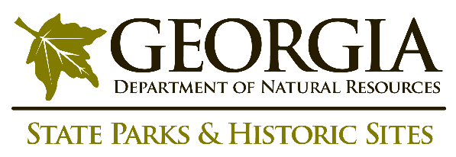
The safety and welfare of staff and the public is a top priority for the Georgia Department of Natural Resources, as we continue to monitor COVID-19 guidance from the Center for Disease Control and Prevention.

